# Lesson 02 – Introduction to JQuery

# Session 2 Worksheet

# Exercise 2:

JavaScript syntax:

<https://www.w3schools.com/js/js_syntax.asp>

<http://www.w3schools.com/js/js_variables.asp>

Go to <https://www.codeply.com/p/muGQonkxFX> , **fork it** and write the jQuery code from Lines 15 to 19.

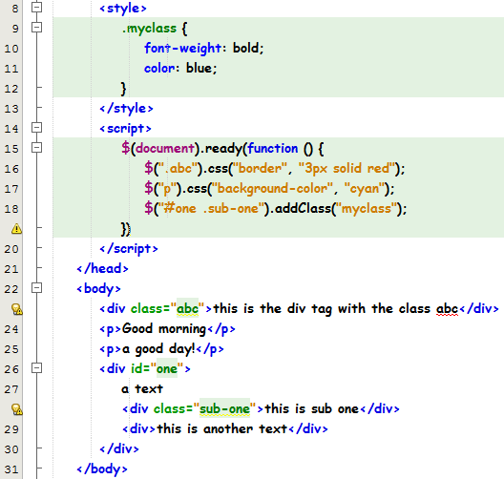

Line 16 – All elements of class “abc” will have a 3 pixels red border. The css() method sets or returns one or more style properties for the selected elements.

Line 17 – All paragraphs will have the cyan background colour.

Line 18 – All elements of class “sub-one” with parent element of id “one” will be effected with the style class “myclass”, which has bold and blue font.

Run exercise2.html and you should see the output below:

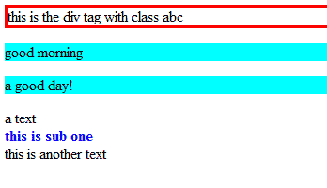

# Submission (make sure you have login-ed to Codeply, forked the code and saved)

|  |
| --- |
| https://www.codeply.com/p/nCOFxH0xfM |

# Exercise 2a:

Open <https://www.codeply.com/go/LZ2lVS2ZOK>, fork it and write the JQuery code to display the following effects:

* The text “Hi!” in green colour
* All paragraphs in italic
* A 2px solid green border around the first and second line
* Change the colour of “First Line” from red to black (remove the class)
* Append “John Smith” to “First Line”
* Prepend “Hello World” to the first, second and third lines

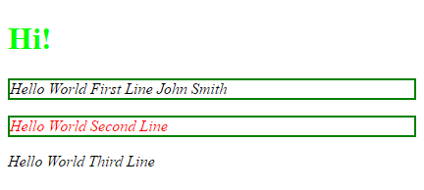

# Submission

|  |
| --- |
| https://www.codeply.com/p/gniJMTeHQ2 |

# Exercise 2b:

Open <http://codeply.com/go/0LEwLrwkx1>, fork it and write the JQuery code to achieve the following effect:

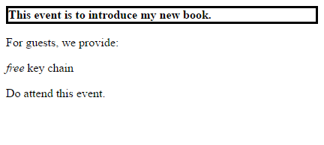

# Submission

|  |
| --- |
| https://www.codeply.com/p/AeRj7mAzgN |

# Exercise 2c:

Open <http://codeply.com/go/szlvdbhgkv>, fork it and write the JQuery code to achieve the following effect:

* All elements with class "back" will have its text made uppercase
* All <ul> elements will have the style class "top"
* All <li> elements inside <ul> elements will have an inline display
* All <a> elements inside elements with id "friends" will have:
  + font color of #0087cc for resources (href) ending with “.com”
  + style class "nav"
* All <a> elements inside elements with id "social" will have a lightblue background color for even numbered ones and lightpink background color for odd numbered ones.
* All odd numbered <a> elements inside elements with id "social" will have a lightpink background color
* The last <p> element will have a font size 8 pixels

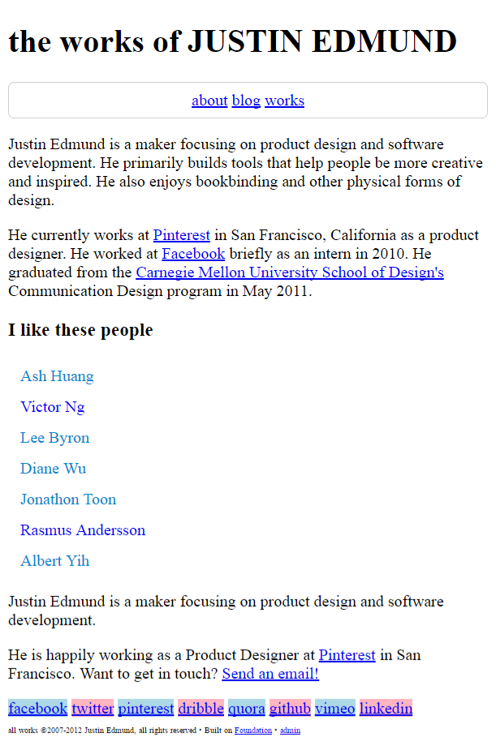

# Submission

|  |
| --- |
| https://www.codeply.com/p/jCiVFChnUL |